Don’t take your ability to hear for granted.

If you are not careful, you can lose your hearing. If you are exposed to very loud noise or moderately loud noise for an extended period, you must take some form of hearing protection precautions.
When must hearing protection be provided and worn?
- The “Best Practices” approach to hearing protection requires that whenever a worker’s noise exposure is at or above an 8-hour average of 85 decibels, hearing protection should be worn.
- The best defense against hearing loss is to use engineering and work-practice controls to eliminate the excessive exposure wherever possible.
- If you are exposed to loud noises intermittently - wear protection.
- Rule of thumb: If you have to raise your voice to talk to someone, you are in an area where the noise level is at or above 85 decibels, and you should be wearing hearing protection.
How can noise exposure be reduced or eliminated through engineering and work-practice controls?
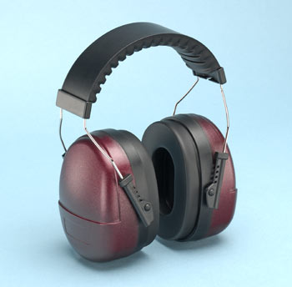
- Periodic rotation of workers to less noisy areas.
- Adding or replacing mufflers on motorized or pneumatic equipment.
- Following equipment maintenance procedures to keep bearings and other moving parts lubricated.
- Isolating loud equipment such as compressors and generators away from work areas.
- Replacing older, noisier equipment with newer, quieter models.
- Installing sound absorbing materials on walls and ceilings.
What are the types of hearing protectors?
- Foam plugs: Disposable and cheap with good noise reduction ability. Insert correctly to ensure the plugs expand for maximum hearing protection.
- Reusable plugs: Provides protection similar to foam plugs, but are made of PVC or a polymer blend. Good for people who are allergic or sensitive to foam plugs.
- Canal caps: Designed to fit into the outer ear and to be held in place by a headband. Good for situations where protection must be removed frequently.
- Ear muffs: Come in a range of noise reduction levels to meet different needs. More comfortable than plugs or canal caps.

Know the noise level of the job and how long your exposure will be. Then use the information provided by your safety supplier to select the best hearing protection.

This form documents that the training specified above was presented to the listed participants. By signing below, each participant acknowledges receiving this training.

Organization: Date:

Trainer: Trainer’s Signature:

Class Participants:

Name: Signature:

Name: Signature:

Name: Signature:

Name: Signature:

Name: Signature:

Name: Signature:

Name: Signature:

Name: Signature:

Name: Signature:

Name: Signature:

Name: Signature:

Name: Signature:

Name: Signature:

Name: Signature:

Name: Signature:

Name: Signature:

